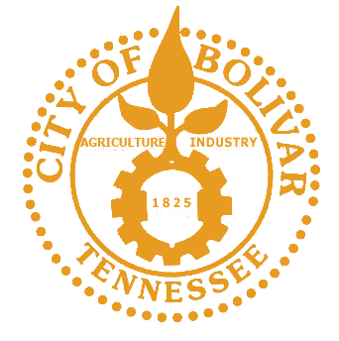
PRESS RELEASE
For Immediate Release

Contact: Sarah Rice
Ph. (731) 658-9545
Email: sarah.rice.cityofbolivar@gmail.com

City of Bolivar Hosts Public Comment Forum on the Reopening of Blossom Park
Bolivar, TN| September 9, 2026
During the regular council meeting on September 8, 2025, the Bolivar City Council held a public comment forum to discuss the addition of amenities at Blossom Park, a neighborhood park that was disassembled years ago. The meeting brought together residents from the affected neighborhood to share their thoughts on the proposed project, which includes already installed playground equipment donated to the city, basketball goals, and a walking track. The public's opinions, both for and against certain amenities, were heard by city officials.
Mayor McTizic opened the forum by addressing the history of the park, which was removed due to what has been described as negative conduct from some members of the public at that time. He made a clear statement in favor of the park's return, arguing that it would not be right to penalize today's youth for the conduct of those using the park 20 years ago. This sentiment set the stage for a productive discussion focused on providing a safe and positive space for current and future generations of children in the community.
The rebuilding of the park is part of a broader effort by the city to invest in public spaces and provide recreational opportunities for its residents. While some community members expressed concerns about the potential for past issues to resurface, others spoke enthusiastically about the benefits of a nearby park for their children and the neighborhood as a whole.
"The future of Blossom Park is in our hands, and I have no doubt that by working together, we can ensure its success for generations to come. I want to extend my heartfelt thanks to everyone who came out to the public comment forum. Your voices, your passion, and your commitment to this community are what will make this project a true success."

