FOR IMMEDIATE RELEASE

**Subject:** Groundbreaking Ceremony Marks the Rebirth of Decatur County Community Hospital

**Parsons, Tenn.,** - BradenHealth, a leading healthcare company focused on revitalizing failing rural hospitals and rebuilding failed rural hospitals, held a groundbreaking ceremony today for the rebuilding and reopening of the former Decatur County Community Hospital. The hospital, which closed amidst financial challenges, alleged fraudulent operations amidst the height of the Covid-19 pandemic and was subsequently damaged from heavy flooding, is now poised to soon serve the community with comprehensive healthcare services.

The ceremony was attended by Dr. Beau R. Braden, DO, MPH, MS, CEO, and founder of BradenHealth, Kyle T. Kopec, Chief Compliance Officer, Vice President of Government Affairs, and co-founder of BradenHealth. Also present were U.S. Congressman Mark Green, M.D., who is passionately advocating for the hospital's certification with Medicare, Senator Page Walley, a key figure in overturning Certificate of Need legislation to pave the way for the hospital's reopening, and Senator Ed Jackson, a dedicated member of the health committee. These elected officials have demonstrated immense commitment and passion for improving rural healthcare.

The Decatur County Hospital project represents BradenHealth's unwavering commitment to addressing the healthcare needs of underserved rural communities in Tennessee. With the support of influential leaders and the community, BradenHealth aims to reverse the climbing death rates resulting from the hospital's closure and restore access to quality healthcare services. This hospital when complete will represent another milestone in the company’s mission to reopen the failed 17 rural hospitals while preventing other distressed hospitals from closing in the state.

Before construction commences fully, authorization and approval are required from the Tennessee Health Facilities Commission and the Tennessee Department of Health. These regulatory bodies will review the project and consider the necessary waivers and building permits to ensure compliance with all healthcare standards and regulations. Senator Walley, and state officials are working to diligently obtain the last approval in this process.

Dr. Beau R. Braden, CEO of BradenHealth, expressed his excitement about the project, stating, "Today marks a significant milestone in our mission to rebuild and reopen yet another failed rural hospital in Tennessee. We are determined to provide comprehensive healthcare services to the residents of Decatur County and address the alarming rise in mortality rates resulting from the hospital's closure. Together with our esteemed partners and the support of the community, we will restore hope and improve the overall well-being of the region."

Kyle T. Kopec, Chief Compliance Officer and Vice President of BradenHealth, also shared his enthusiasm for the project, adding, "The groundbreaking ceremony signifies a collective effort to overcome the obstacles that have plagued rural healthcare in Decatur County. We are grateful for the commitment of Congressman Mark Green, Senator Page Walley, Senator Ed Jackson, and their direct effort to rebuild the Decatur County Community Hospital. They are personally championing this cause. Their dedication will enable us to provide critical healthcare services that are essential to the community's prosperity and vitality. Senator Walley’s legislation is a huge milestone for Tennessee, and he should be proud of his direct impact in fixing the rural hospital crisis."

**Attachments (Event Photos):**

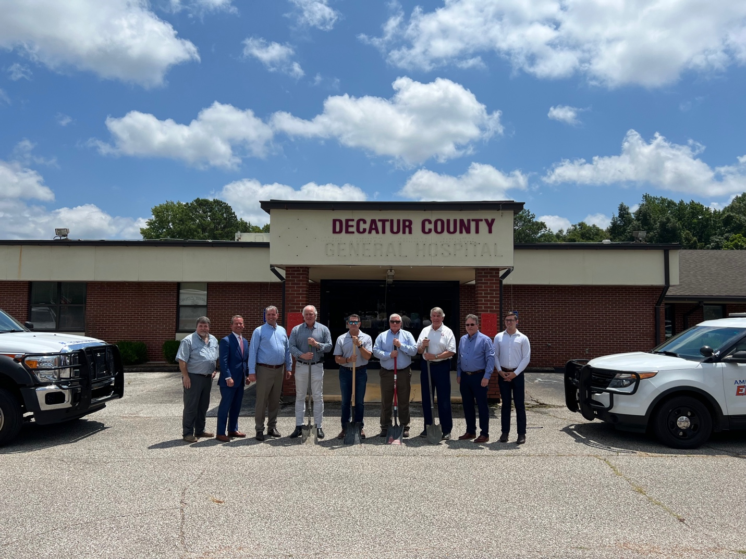

**(Left to Right: T. Stewart, Project Manager, M. Banks, Haywood Hosp. CEO, Dr. B Braden, BH CEO, Sen. P. Walley, Rep. M. Green, M.D., Mayor M. Creasy, Sen. Ed. Jackson, G. Stewart, Henderson Hosp. Ceo, K. Kopec, BH, CCO & VP).**

**(Left to Right: T. Stewart, Project Manager, M. Banks, Haywood Hosp. CEO, Dr. B Braden, BH CEO, Sen. P. Walley, Rep. M. Green, M.D., Mayor M. Creasy, Sen. Ed. Jackson, G. Stewart, Henderson Hosp. Ceo, K. Kopec, BH, CCO & VP).**

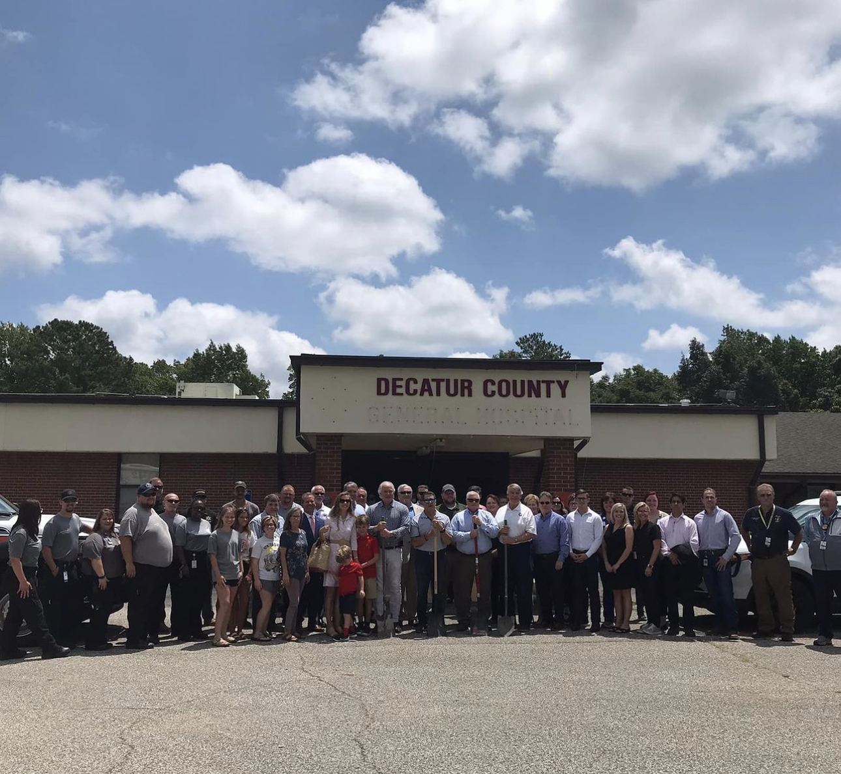

**Crowd gathered at Decatur for ceremony.**

**(Left to Right: Rep. M. Green, M.D., K. Kopec, CCO, BH, listen to Dr. B. Braden, CEO discuss plans for the site, Sen. E. Jackson, and S. Braden in the background).**

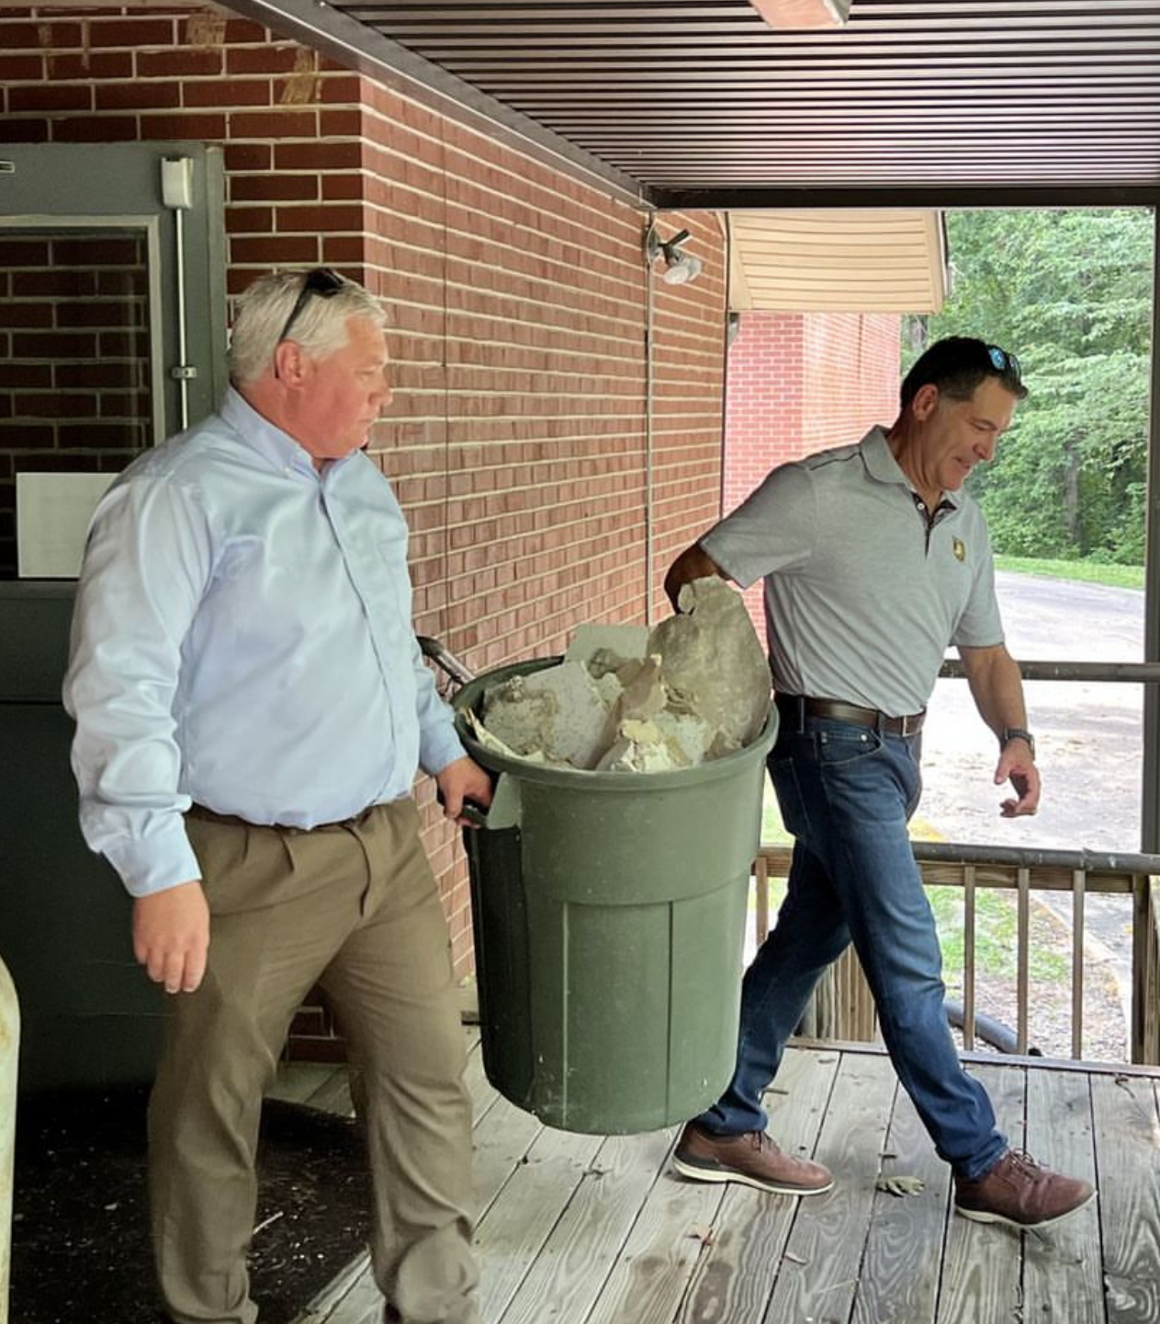

**(U.S. Congressman Green, M.D., carries the first trash bin of rubble to a dumpster signifying the start of hospital renovations to gut the damaged facility of flooded rubble, and a collapsed ceiling).**

###

For media inquiries or further information, please contact:

Zachary Feldman

Deputy, Compliance

Director, Special Projects

[Zachary.Feldman@BradenHealth.com](mailto:Zachary.Feldman@BradenHealth.com)

<https://decatur.health>