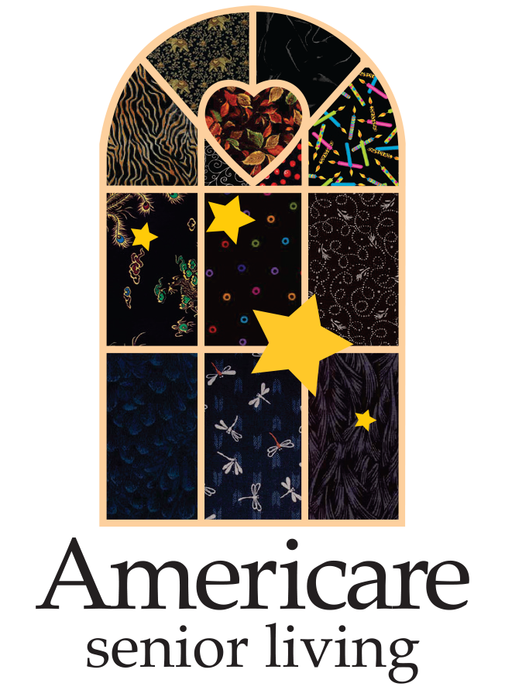
Contact:
Ralph Berry, rberry@sullivanbranding.com
901-486-4269

Josephine Owino of Alexandria Place in Jackson, TN Named
Americare Senior Living Caregiver of the Year
May 22, 2023 — Josephine Owino, a 13-year caregiver at Alexandria Place has been awarded the prestigious Mary Ann Hess Caregiver of the Year Award at Americare Senior Living. Josephine was selected for the award from more than 4,000 caregivers across 109 Americare communities in Missouri, Tennessee, Kansas, Illinois and Mississippi.
The Caregiver of the Year distinction goes to one individual who best exemplifies Americare’s philosophy in the delivery of outstanding resident care and customer service. This award seeks to highlight an individual who not only provides outstanding resident care themselves, but has influenced the quality care provided by co-workers.
Jo has been a center of caring and personal dedication to residents since joining the community 13 years ago. In fact the word “center” seems particularly appropriate in describing Jo as she was a center for the Union University basketball team and is the only Union University player, and the first Kenyan, to be drafted into the WNBA when she was selected by the Washington Mystics in the 2009 WNBA Draft. Jo was inducted into the Union Hall of Fame in 2017. She earned her degree in sports medicine from Union.
However, it is Jo’s unwavering caregiving and compassion, not her skills on the basketball court, that has earned her the highest recognition at Americare. A very versatile employee, she has worked all 3 PCA shifts as well as serving as the Dietary Manager, as Interim Lifestyle Coordinator and as lead trainer. To assist during staffing shortages and special care needs, she has volunteered to work in many Americare sister communities, even traveling over three hours, sacrificing countless nights, weekends, and holidays.
“Jo is a very special person with a knack for discovering what our residents might be missing in their lives and stepping in to fill that void,” said Jennifer Brewer, administrator at Alexandria Place. “We have had several seniors without families or whose families live very far away and she always adopts them to make big deals out of birthday celebrations and just give them extra TLC. Simply put, she is an exceptional human; one who brings light, laughter and love to all those around her; I cannot imagine a person more deserving of this prestigious award than Josephine.”
Not only does Jo serve the residents at Alexandria Place, she a valuable assent to her family back home in Kenya, 8,000 miles away. Jo supports her family in an area where there are very limited resources and access to medical care. They take in children who have lost their own families despite having experienced many difficulties of their own.
Nominations for the Caregiver of the Year Award are submitted and reviewed by a panel of individuals selected with the help of the National Association of Certified Nurse Aides. No members of the judging panel have any ties to Americare and review each nomination on its merits – never knowing the name of the nominee or the location of their community.
Alexandria Place is located at 108 Physicians Drive in Jackson. It offers six types of living options: assisted living, respite care, rehabilitation care, adult day care, hospice care and home health care for skilled nursing visits. For more information visit www.americareusa.net/senior-living/tn/jackson/alexandria-place.
About Americare: Since 1981 Americare has been providing high quality skilled nursing and senior living services. With nearly 4,000 residents and 4,000 care professionals, Americare is guided by a philosophy prioritizing the needs of residents and the employees who serve them. Now more than ever Americare has the experience that matters most to families and employees. For more information visit www.americareusa.net.

